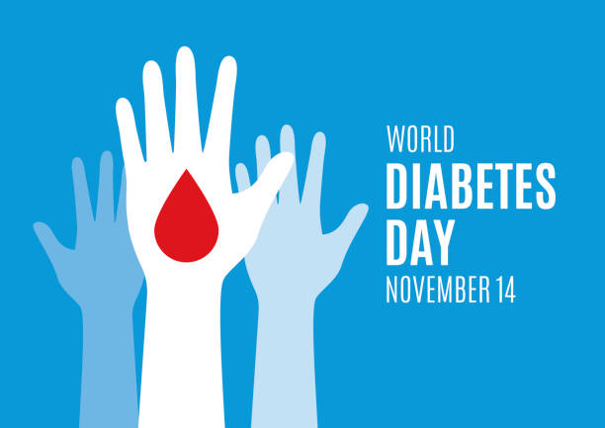

This year our school is taking part in World Diabetes Awareness Day. Every year on November 14th, the world takes some time to bring awareness about a health condition called diabetes. Diabetes is a condition where your body is unable to turn the food you eat into energy. Your body needs insulin to unlock your body’s cells and turn the food into energy. Your entire body is made up of these tiny cells, all different kinds depending on where they are in your body. **Over 29 million people in the world are diagnosed with diabetes every year.**

People with type 1 diabetes have to take insulin everyday, given by a shot or an insulin pump. People with diabetes also need to check their blood sugar at least a few times a day, and they can use a blood glucose meter (pricking their finger as needed), or wear a continuous glucose monitor to check their blood sugar levels. **Living with diabetes is a constant balancing act. It’s like doing everything in your daily life while keeping a balloon in the air.**

So in order to be a support system for those friends and family with diabetes, we encourage you to wear the color blue to school on Thursday, November 14th. Students will even receive a blue ribbon to help share the message. Together we can bring awareness to our community and make a difference.

For more information about diabetes please see the videos below:

[What is Diabetes for Kids Video](https://www.youtube.com/watch?v=m98Stibb-LM)

[World Diabetes Awareness Day](https://www.youtube.com/watch?v=sFxe7k7qAZM)